Fredericktown Community
Joint Emergency Ambulance
District

2021

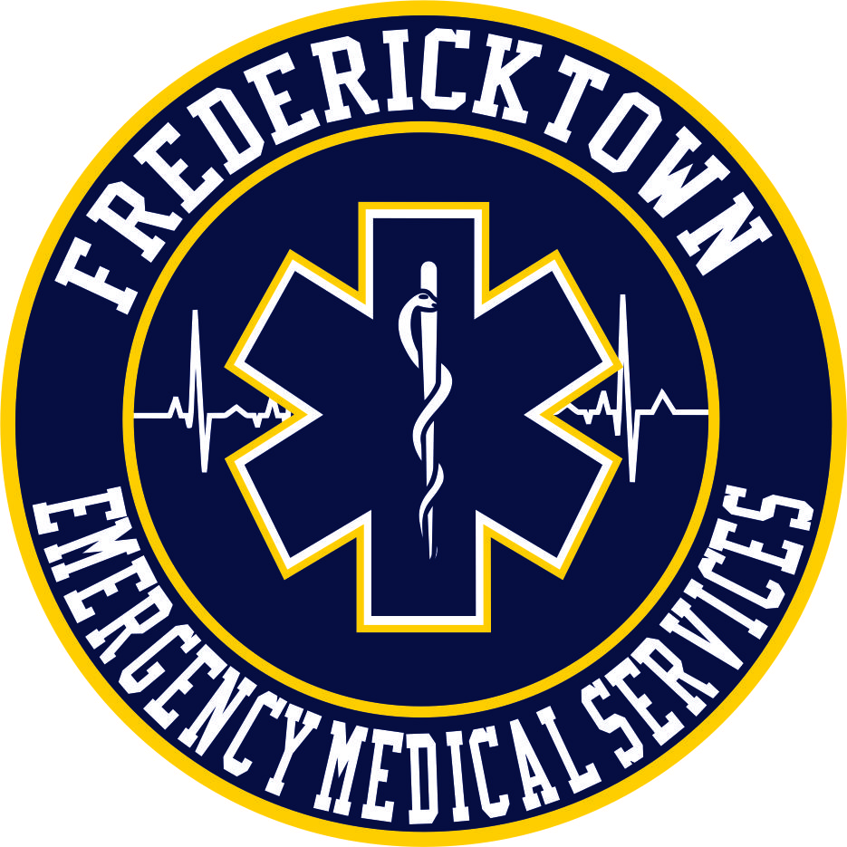

Dear Community Members,

With yet another year in the books, 2021 was busy for the members of Fredericktown EMS. Administering vaccines, adapting to the “COVID” world we now live in and responding to increased run volume are some of the reasons we set new records.

Several of our members participated in state training that allowed them to assist with the COVID vaccination process. Our members worked with Knox Public Health to begin the daunting task of vaccinating those most at risk for COVID. Countless hours were spent preparing and operating mass vaccination drive thru clinics. The weather, mainly bitter cold and snow foiled plans for additional drive thru dates. The cancellations forced KPH to find an alternate location that would allow for drive up and walk in appointments. Energy Fieldhouse in Mount Vernon was selected as the new site for vaccine administration. To say our members assisted in vaccinating thousands of people would be an understatement.

In conjunction with MedFlight of Ohio and Ohio Health Hospitals, on March 18th, Fredericktown EMS hosted a virtual trauma lecture. More than 250 medical professionals form around the nation logged on to watch. Having EMS providers from other states and countries watch some local physicians present was …. to say the least…. COOL!!!

As the weather turned warmer, our run volume began to show signs of increasing. Approximately halfway through 2021 we were seeing trends of a possible record-breaking year.

The Handtevy Pediatric Emergency Standards protocol was implemented and integrated with our EMS protocol. This versatile tool allows for enhanced pediatric emergency treatment. Along with Handtevy, a grant for pediatric training equipment was applied for and awarded to the department. This valuable equipment allows EMS members to better train for treating our younger population.

Whether it is due to a lack of EMS providers or an increase in run volume for all agencies, our mutual aid responses more than doubled from 2020. The increase is not just from one agency, the average for all the agencies we respond to doubled.

For the first time in the history of Fredericktown EMS, members responded to 1,085 calls for service, or 1,117 patient encounters/ reports. This is more than a 15% increase from 2020. While this may not seem like many calls for some departments, keep in mind this was accomplished with two trucks, less than thirty members and we received (or called for help) mutual aid one percent of the time. To put this into numbers, 14% or about 156 runs were for “mutual aid given”. 13% or about 146 runs consisted of both of our trucks assigned to runs at the same time. With both trucks out for calls, we had to depend on mutual aid for 1% or about 14 runs.

The busiest month in the history of Fredericktown EMS occurred in September of 2021. In September we handled 125 runs, closely followed by the third and fourth busiest months of October with 115 and November with 111 runs. The second busiest month in history is October of 2016, with 116 runs.

Saturdays were the busiest day of the year with 172 runs, the 2PM hour was the busiest time of the day with 77 runs, 9 AM – 9 PM was the busiest 12-hour period of the day. On average, it took 1:42 from the time of dispatch until a truck was responding to an emergency call. An average of just under 60 minutes was spent on each call (57:33 Dispatch to call closed).

Over 500 patients were transported to Knox Community Hospital. Nearly 70 were transported to Ohio Health Mansfield. Of these patients, 491 were transported “non-emergency status” with 87 transported “emergency status” (lights & sirens).

We would like to thank the community for their continued support of Fredericktown EMS and for the kindness and respect that you show our members. Without the hardworking, caring, and dedicated members of this department, we would not be the service that we are.

Lastly, we would like to remember the life of Ralph E. Davis, who passed away on May 14, 2021. Ralph spent 38 years caring for those in this community. Ralph was loyal to the department; he would religiously make sure he was available to cover his nights when the department was covered by volunteers. Ralph will be missed, they don’t make them like Ralph, anymore. The “Ralph” stories are too many to recall a favorite, but trust me when I say there are many, one of Ralph’s favorite sayings to the new members of the department was, “boys, you need to slow down, the emergency will still be there when we get there!”.

Thank you,

Chief Rick Lanuzza

